**Name: Amogh Karhadkar**

**USN: 1BM18CS014**

**BDA Lab Report**

**Program 1.** Create a table “Project_details” with primary key as (project_id, project_name). Perform CRUD operations**.**

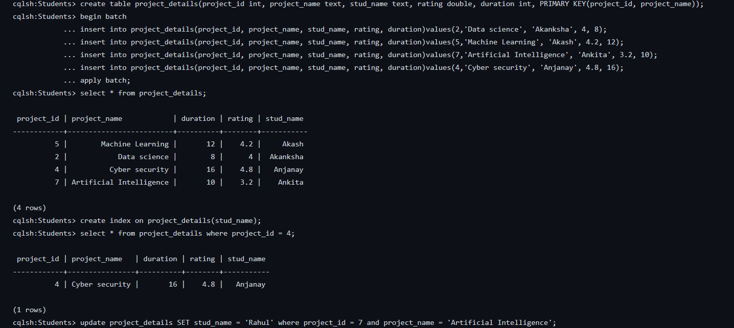

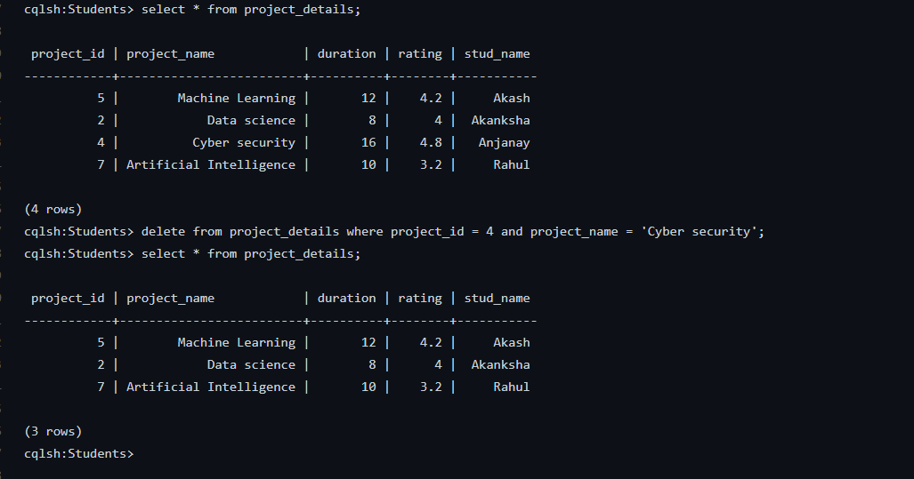

**Program 2.** i) Perform the following DB operations using Cassandra.  
  
1. Create a keyspace by name Employee  
2. Create a column family by name Employee-Info with attributes  
Emp_Id Primary Key, Emp_Name, Designation, Date_of_Joining, Salary,  
Dept_Name  
3. Insert the values into the table in batch  
4. Update Employee name and Department of Emp-Id 121  
5. Sort the details of Employee records based on salary  
6. Alter the schema of the table Employee_Info to add a column Projects which stores a set of Projects done by the corresponding Employee.  
7. Update the altered table to add project names.  
8 Create a TTL of 15 seconds to display the values of Employees.

ii) Perform the following DB operations using Cassandra.  
1 Create a keyspace by name Library  
2. Create a column family by name Library-Info with attributes  
Stud_Id Primary Key,  
Counter_value of type Counter,  
Stud_Name, Book-Name, Book-Id, Date_of_issue  
3. Insert the values into the table in batch  
4. Display the details of the table created and increase the value of the counter  
5. Write a query to show that a student with id 112 has taken a book “BDA” 2 times.  
6. Export the created column to a csv file  
7. Import a given csv dataset from local file system into Cassandra column family

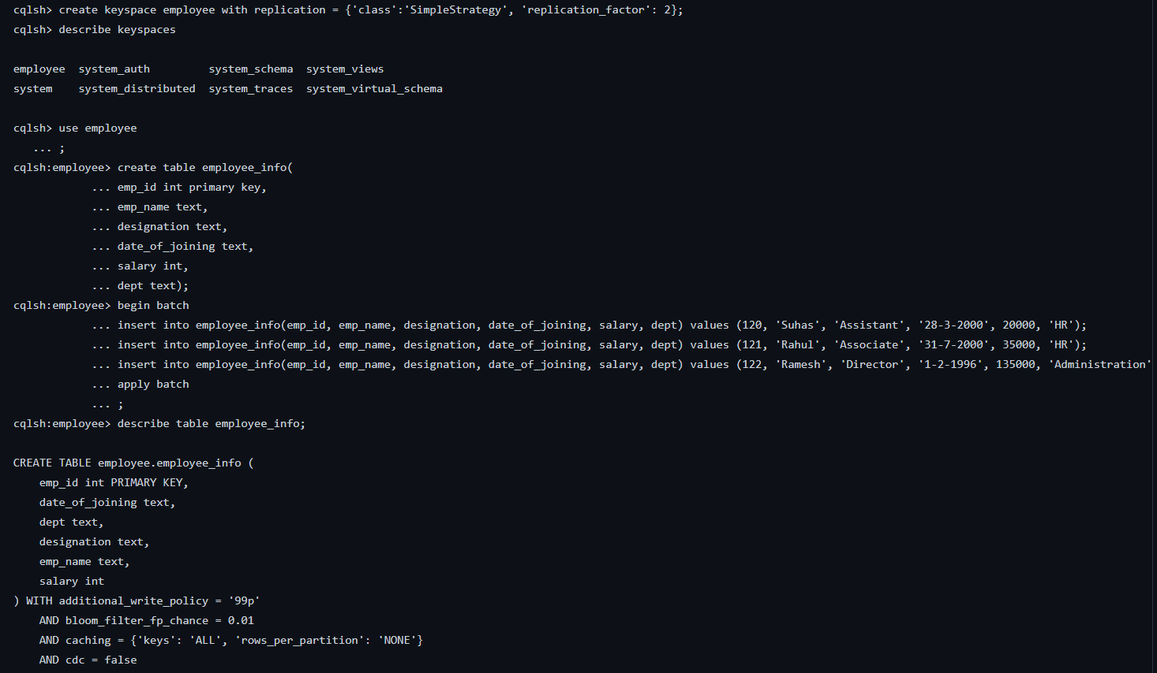

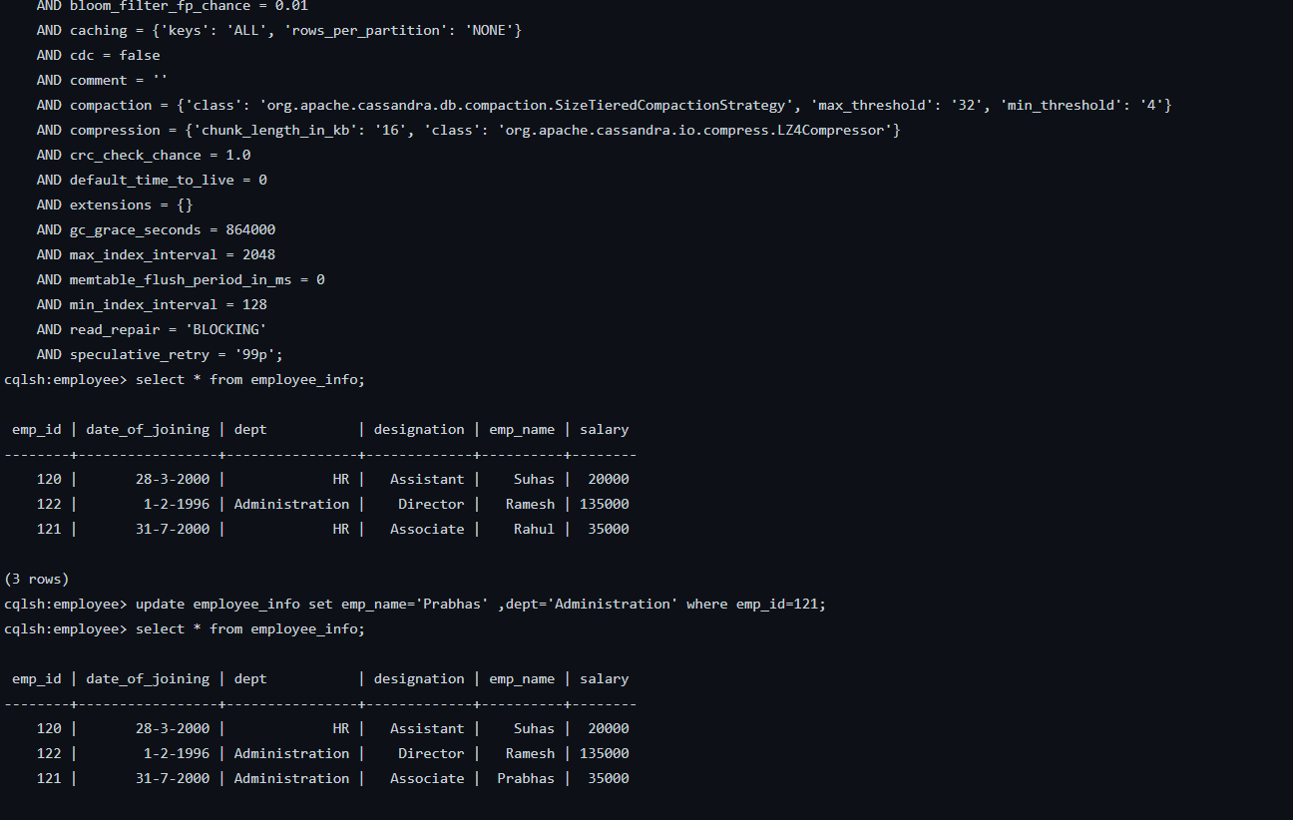

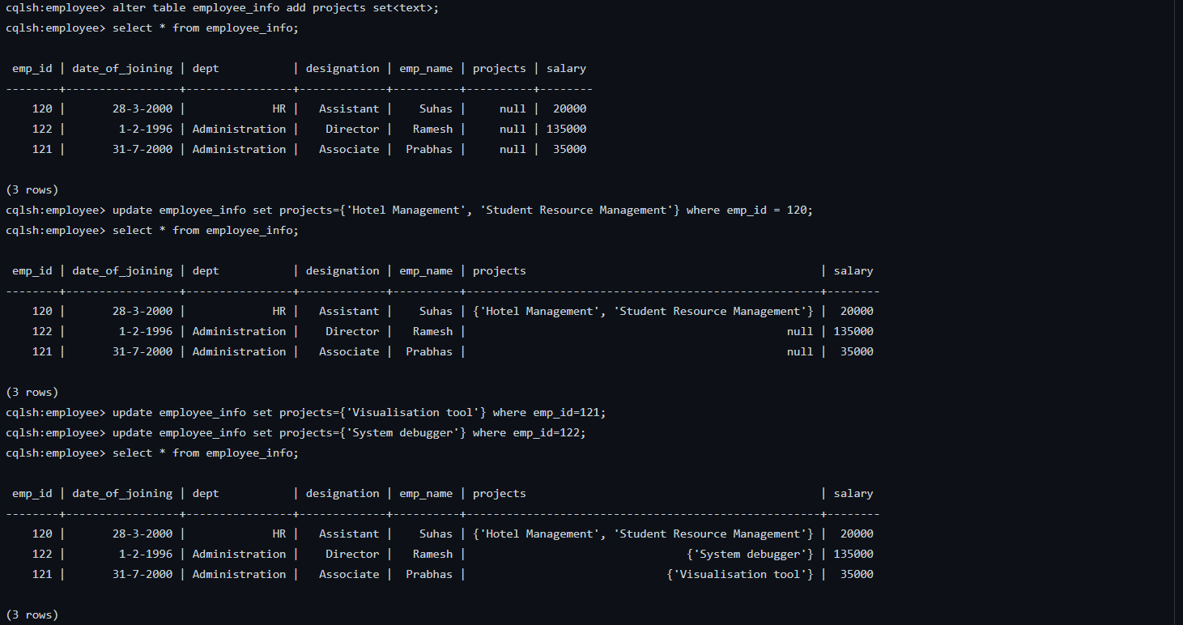

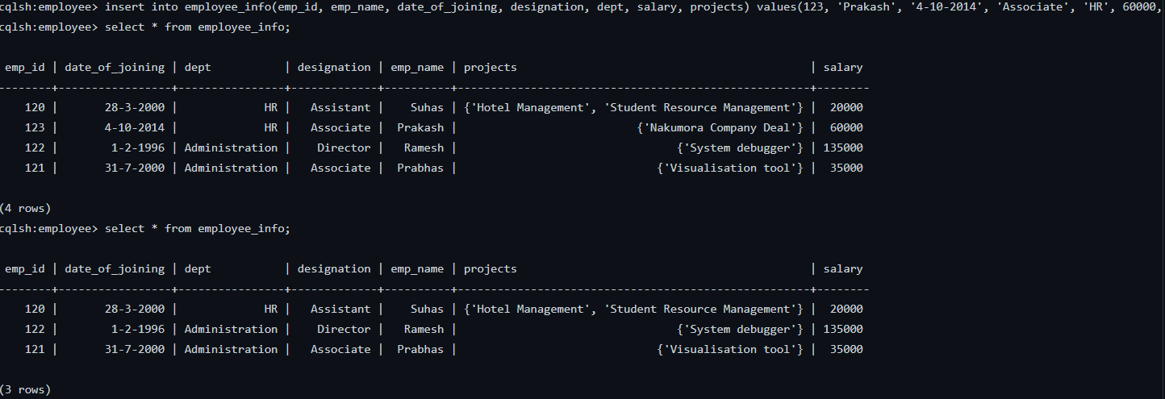

**Program 3**. Perform the following  DB operations using MongoDB.1. Create a database “Student” with the following attributes  Rollno, Age, ContactNo, Email-Id.2. Insert appropriate values3. Write query to update Email-Id of a student with rollno 10.4. Replace the student name from “ABC” to “FEM” of rollno 11.5. Export the created table into local file system6. Drop the table7. Import a given csv dataset from local file system into mongodb collection.

